Recipe to beat the red team

Don't tell anyone!

If you need to beat the red team, its easy, you can just enter the following command, and all your units will become much stronger.

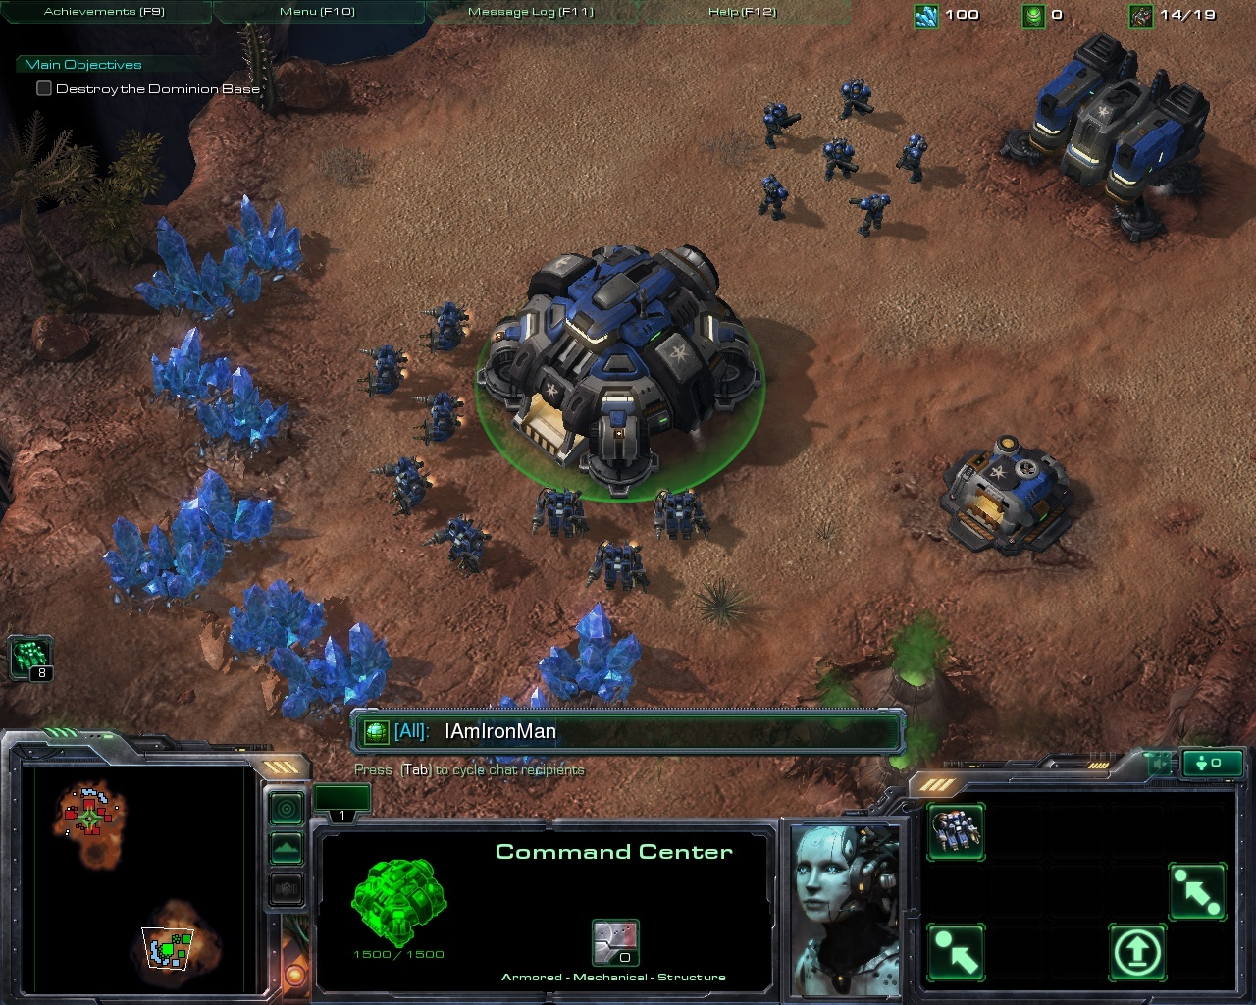

I guaranty that the other team will not realize anything